Abstract Title, Left Aligned, Each Word Capitalized, Calibri Font, Bold, Size 16

Name of Presenting authorª, Name of Author Bª, Name of Author C^{b}…
Format: First name (Middle name(s) initial(s)) Last Name, left aligned, Calibri (Body) font, size 12.
ªAffiliation a…, ^{b}Affiliation b…, (including city/state & country).
Keywords: 3-5 keywords
Your text… [1]. The body of the abstract should be a maximum of 300 words, without considering the references, authors, or affiliations. It may include one figure OR one table. The text must be Calibri (Body) font, size 12, Justify. Please save your document indicating the preferred presentation mode, theme, and name, as follows:
Presentation Type_Theme_LastName_FirstName.docx
Submit your abstract via magic-molfun@biosustain.dtu.dk, using the title of your document as the subject line.
Example 1: Poster_Theme1_Andersen_Eva
Example 2: Oral_Theme4_Rodriguez_Laura

Theme 1: Computational Genomics
Theme 2: Experimental Genomics
Theme 3: Computational Metabolomics
Theme 4: Applied Metabolomics
Theme 5: Integrated Approaches

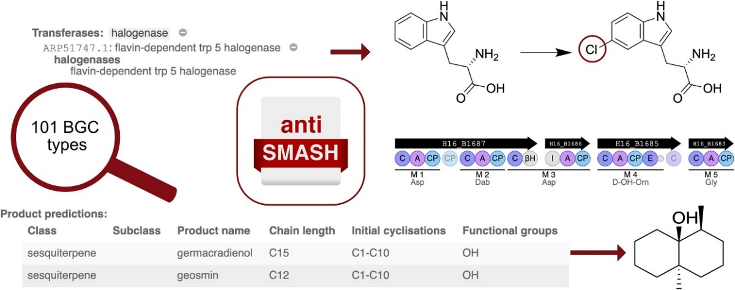

Example figure centred and caption centred in italics…

References
[1] First Author, Second Author,… (Publication Year), Title, Journal, doi:… up to five references.

